Supporting the community to take action: a case study analysing and reflecting on a community campaign in Cockermouth from a number of different perspectives.

Abstract

The aim of this case study is explain the RSLM model used by the community organiser which brought about community action through listening to individuals in the community. The model of work will be analysed upon through the examination of primary and secondary evidence and reflected upon through the writings, research and experience of other community organising approaches, community capacity building and community development.

I will be sharing my personal reflections of my own experience of working on the campaign from my position as a Trainee Community Organiser (TCO) and sharing my learning journey. Alongside my reflection will be two others: one of whom, Maralyn, experienced the campaign from being intrinsically involved in the movement and the other, Hannah, a professional who will offer objective reflections based on her position and experience.

This case study follows the experience of a one-to-one listening leading to group action. Detail of how the TCO met the resident in the community and how trust, respect and relationships were built will be explained. Using the RSLM approach I encouraged the resident to gather likeminded people to develop a house group who then led the campaign and made decisions and an action plan. The method of personal development leading to local action leading to wider society will be explored in this case study. Contacting the local paper for media coverage was one of the decisions the group made and references to these articles will be made. Evidence of correspondence between the campaign group and Cumbria County Council will be reflected on by myself, Maralyn and Hannah.

References will be made throughout the case study to compare and contrast approaches to Community organising with those of renowned authors and community organisers. The experiences of the case study will be compared to experiences of other community organisers and other case studies.

Method of organising

The primary contact with the Root Solutions Listening Matters (RSLM) Community Organising Model came through the initial job description. The Key Objective is:

To learn how to ( a) motivate and organise people in neighbourhoods by using “Root Solution - Listening Matters” organising strategy and process and (b) to incorporate later, other tools and approaches for animating, developing, catalysing and focussing community action. (Diamond, 2011)

Trainee Community Organisers (TCOs) were asked to attend a three day intense training course provided by Re:generate prior to taking on their employed roles. During the 51 week contract the TCOs were also expected to complete the Foundations of Community Organising (OCN accredited) and a ‘Go Deeper’ module. The purpose of the initial training was to give TCOs a broad background to the model of community organising developed by Re:generate, called RSLM (Root Solutions Listening Matters) and to practice some of the skills needed for work on the ground. RSLM is described as:

“a learning and action-based programme created to support transformational change in individuals, groups, organisations and institutions. The foundation of the work and training is 1:1 systematic listening and dialogue that builds trusting, respectful relationships, networks and connectivity between and across diverse communities that stimulates action for transformation that shifts power relationships.” (Diamond, 2011)

The TCOs are employed for 51 weeks by Locality. As a fully qualified Community Organiser it is expected that the community will match fund Government funding from the Office for Civil Society to the tune of £15,000 and as the value of Community Organisers becomes apparent, the community will seek to fund the Community Organiser completely in subsequent years. The model for community organising therefore becomes self-sustaining and owned for and funded by the community in which the Community Organisers will work. In this way the Community Organisers are answerable to the community and being owned by the community ensures that the work continues to address the agendas of the community and not the agendas of larger funding bodies.

Listening Matters originated in the 1980s and by 1999 Action to Regenerate Community Trust had been created through the action of listening which had built trust, respect and relationships within the community. I spent a year in the community listening to people about how they felt about their community and their ability to have a voice and after only a few weeks of listening there was a clear feeling of apathy that had developed making people feel that voting was pointless, that decisions had already been made, making consultations only insulting to the population and a waste of time and taxpayers money. Kearney and Olsen (2009) state that:

“Politicians and public servants are growing more and more desperate to engage with
citizens. They are under pressure to deliver services ‐ and keep the nation comfortable. Yet
people in Britain no longer appear to trust politicians ‐ or to see the point of using their vote,
or their voice. This is dangerous for democracy. They need a process to change this.” (Kearney and Olsen, 2009)

The RSLM process starts with the community organiser listening to individuals on a one-to-one and when someone is angry or raises a particular concern, the community organiser asks them to identify other people that they know who feel the same and in so doing, gather those people he/she knows together for a ‘house meeting’ to discuss the issue. Through a group listening known as a ‘house group’ the members of that group are encouraged to go out and listen to others and extend their network to find others who feel as passionately as they do. Listening within the community brings the community closer, building trust, respect and relationships but fundamentally a network of people in support of a particular issue or campaign. The greater the number of people, the greater the impact of power and voice they have on local MPs and Councillors. Encouraging people to vote and be engaged in what is happening is key to the RSLM approach.

Kierney and Olsen (2009) developed a model called the Spheres of Influence (diag1) to demonstrate the influence of the three types of development and the impact they have on each other. By working with individuals on a personal level, i.e. one-to-one can lead to Personal Development which develops into Local Action which in turn affect Wider Society. One of the mantras of RSLM is not to do anything for anyone if they can do it for themselves, thereby allowing someone to develop.
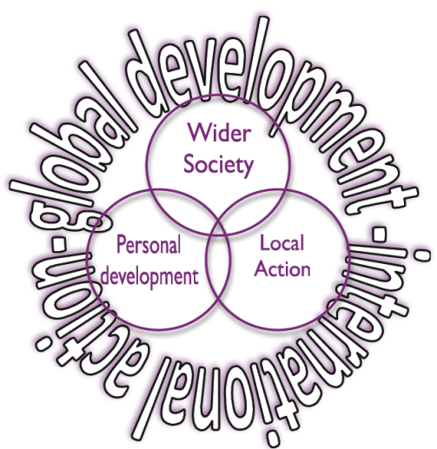

Diagram One (Kearney and Olsen, 2009)

Another key trait of the RSLM Model is in the finding of the ‘root’ cause of a problem. So often society is organises from the top down, from those in power who make the decisions leaving those on the ground to adapt to the changes. Root solutions is about finding out from grassroots what the issues are and asking those at ground level to identify solutions that they believe will work. The information gleamed from one-to-one listenings is not shared with any Government Agencies for the purpose of statistics but kept within the community. As the network grows, a Community Holding Team is formed and the Community itself is the keeper of all the listenings. This model of working felt ethically correct and as a person who prides herself of the quality of personal relationships with people; listening and keeping confidentiality felt like the right thing to do. In using this method I was able to listen to the community campaigners with open questions which ensured that I wasn’t bringing in an agenda which was irrelevant to them. This part of the RSLM Model is called ‘No Data Mugging’. By having a service designed by the community it will naturally be more fit for purpose and they will feel ownership of it.

As with many community organising models, RSLM teaches the importance of reflection (diag2). The TCOs are encouraged to reflect daily about their listenings, weekly in a team reflection and encourage community members to reflect on listening and action in order to learn from experiences and plan the way forward.

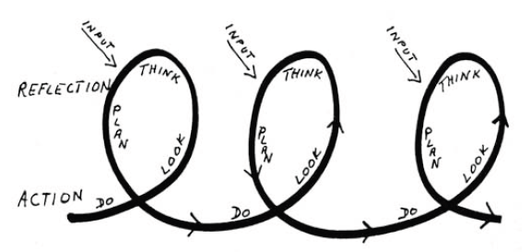

Diagram Two (Kearney and Olsen, 2009)

Trainee Community Organiser in action

On the 25th November 2011 Maralyn contacted the Kirkgate Arts Centre after listening to the local paper on a ‘Talking Paper’. The TCOs had recently started their role in the town of Cockermouth, Cumbria and their Host Organisation arranged for some local media coverage to introduce them to residents of the town (Appendix One). The message Maralyn had left was passed to me who immediately returned the call. The conversation was a brief one due to the crowded office space in which I was standing. I engaged Maralyn immediately by asking her to explain why she felt inspired to get in contact. The initial concern was over some fallen leaves on some steps outside the Sheltered Accomodation where Maralyn lived. A snap judgement would have ruled that this was a street cleaning issue and one that might better be directed to Allerdale Council. However, a snap judgement was not made and Maralyn’s concern over the safety of the steps was reflected back to ensure the issue had been understood and heard.

In order to get to deeper matters, face to face contact is preferred by the TCOs on the Locality programme. Their training encouraged listening to people in the community on the doorstep and in their own homes because this is an environment which is comfortable for the person being listened to. The more comfortable a person is, the greater the possibility for in depth listening. It was arranged that Maralyn would welcome a visit from me so that I could see the steps myself.

Maralyn pointed out the steps and then proceeded inside to talk some more. TCOs had been trained to use a series of questions called RSLM (Root Solutions Listening Matters), a copy of which can be found in Appendix Two. The copy given in Appendix Two is the original record of the conversation between myself and Maralyn. I do not like to write while listening because I am then compromising the quality of the listening. Instead I wrote on a notepad, key words and issues which I later wrote up onto the RSLM form. The completed form however does not show how I deviated from the structure of the questions. The deviation was in the form that Maralyn had initiated the conversation by talking about her concern and so it seemed natural to deal with this main issue first. Maralyn was asked what could be done about the steps and how she could take action. Maralyn explained that she had phoned the council and they had cleared the leaves but explained that there was an overhanging tree which was causing leaves to drop on the public steps. Maralyn was asked how the root problem, i.e. the overhanging tree might be dealt with.

Although I had my own ideas as to how the problem might be solved, I rigorously kept to the training I had received and asked Maralyn what forms of action might work. Freire’s mission was to ‘give the oppressed people the tools to their own liberation’ (Blackburn, 2000). The training does not teach Trainee Community Organiser how to solve community problems but teaches to empower people through good listening, reflecting back what has been said and teasing out ideas, so that members of the community can use the skills, knowledge and energy they already have to create action. Other trainees like myself had little prior experience of Community Development or Community Organising and we were all from a variety of educational backgrounds which showed that Locality were not looking for people who thought they had all the answers. They were looking for trainees who would be open to supporting the community to make decisions of their own. This enables the community to take greater control over their local environment which is the beginning of community capacity building. Community capacity building was defined by Noya, Clarence and Craig (2009, 163):

‘Community Capacity Building: A process of enabling those living in poverty to develop skills and competencies, knowledge, structures and strengths, so as to become more strongly involved in communities as well as wider societal life, and to take greater control of their own lives and that of their communities’

The RSLM model of community organising shares the same mission of developing ‘skills and competencies, knowledge, structures and strengths’ however does not aim its direction only at those who are poor. The mandate for TCOs is to listen to everyone in the community because even when someone isn’t poor, they may still lack the skills to improve their own lives and their communities.

Maralyn has been a very successful and confident individual in her lifetime but her age now means she falls under the category of ‘Vulnerable Adult’ and her failing eyesight has had an impact on her confidence as well as her physical ability to be able to read documents and write letters. Community capacity building in the RSLM model includes everyone in the community because everyone has the ability to develop new ‘skills, competencies, knowledge, structures and strengths’ allowing them to better engage with the communities in which they live.

After some reflection Maralyn had found a solution which involved highlighting the problem to the Supported Housing Manager who would be able to ask the Maintenance Man to cut the branches back as the tree was in the boundary of the Supported Housing Complex. The model of community organising used avoided closed questions giving the resident answers which would have suggested that the TCO had more knowledge and power than the resident. I was careful to ensure that Maralyn answered her own questions to make her realise that she has all the ideas and information herself and it only needed herself to unlock that powerful source of knowledge and drive to get the problem sorted.

Maralyn felt elated by the conclusion that she was able to do something about this problem and she had agreed with me, that by next week she would have spoken to the Manager. Maralyn’s development started through personal development as she explored the power she had within her to tackle the issue of the slippery leaves on the steps outside her home. An Individual Action Plan had been set where Maralyn had agreed to make an appointment to see the Manager and explain the problem and give the Manager a resolution by the following week. I continued with her RSLM questions and asked what should have been the first question of the conversation ‘What do you love about your community’. Maralyn was apologetic for not having praised all that was good about Cockermouth and clearly loved her community within the Supported Housing Scheme but also in the Methodist Church and the local community of Cockermouth.

Maralyn lives in the community of Cockermouth but as Gilchrist (2009) points out there are other communities that people are part of. A community can be defined as a group of people with whom one shares ‘mutual commitment, belongingness, and interdependence’ with (McMillan & Chavis, 1986). When Maralyn answered my question about her community, she identified three communities that she was part of: Cockermouth town community, the community in her Sheltered Accomodation and her community of friends at church. Maralyn belongs to the Methodist Church community and the WCSB (West Cumbria Society for the Blind) which were key supporters of her campaign. These groups, ‘communities of identity or interest can thus be seen as a device for collective empowerment and is a familiar strategy for countering the dimensions of oppression’ (Gilchrist 2009, 5). In the case of Maralyn this may be the oppression of increasing age and deterioration of sight. As one get older one loses confidence and is much slower at adapting to change and can hence feel less able to engage and be an active citizen. Deteriorating sight means that one is not able to do certain practical tasks such as writing a letter, reading a voting slip or reading street notices which are primary forms of activism.

Maralyn met with a group of people who belonged to the WCSB once a month. Having praised all that she loved about her communities, she naturally progressed onto another concern over the difficulty she had crossing Lorton Street because there isn’t a pedestrian crossing. Using RSLM she was asked about what she would like to see to tackle the issue and how this might be achieved. Once again I ensured that I didn’t suggest or answer how the problem could be tackled but let her make the decision based on her personal experience and knowledge. I asked if she knew other people who found the road difficult to cross and she was able to name a dozen people, all of whom she met at the monthly WCSB meeting. An action she was keen to take was for a petition but she was unable to formulate a petition sheet herself due to lack of sight and hence I agreed to create a simple format for her.

The golden rule of this model is not to do anything for anyone that they can do for themselves and up to this point, Maralyn had done everything but creating a petition form was not possible and it then became appropriate for me to offer to help. Alinsky would have been happy with the RSLM approach which starts with listening and winning trust and respect from the individual (Thomson, 2005). The RSLM mantra of ‘Never do anything for anyone that they can do themselves’ (Kearney and Olsen, 2009) was rigidly kept, empowering Maralyn to address the issue herself and by gathering other people she trusted together who felt similarly to seek solutions. I asked Maralyn at her next meeting with her friends at WCSB to explain that she had spoken to me and ask her friends whether I could attend the next meeting to listen to them. An important part of the RSLM model is building up a network of support and the easiest and most comfortable way for people to do this, is to start with warm contacts: family and friends. Maralyn felt comfortable with this group of friends and felt comfortable to share her concern and ask whether they felt similar and strongly enough to support a joint campaign.

The RSLM model of working places great emphasis on the need to build a network of support. The TCOs were asked to listen to individuals and once an issue or passion had been identified, explore it with them and let the resident identify others from the soft contacts they have, who may feel similar. The resident is then encouraged to listen to others and record the listenings on the RSLM forms. Maralyn was unable to do this due to her lack of sight and she was asked to go along to her group and ask them specifically about the issue of the crossing to gage whether the issue was one which affected only herself or whether it was a wider issue. It would have been unreasonable for me to have expected Maralyn to remember the format of questions on the RSLM form which is why I gave her the task of listening on that one issue only and I explained that when I attend, I will be asking all the questions in relation to the community and engagement. The building of a network is seen as key to many community organising processes because it provides the build up of a power base.

For Alinsky, network building is vitally important to community organising because he recognised that an organisation has power and therefore it is important to win residents over to the idea that by organising, they too can have power (Alinsky, 1971). The training we received gave great emphasis to the importance of encouraging people to get house groups together which consisted of people who knew each other well enough to have trust, respect and relationships which means they were able to organise themselves. Freire also comments on organising as being a group activity and identifies that leaders of those groups have an important role in stopping action from time to time, in order to reflect on what has already happened (Horton & Freire, 1990). In this case the leaders were myself and Maralyn. When we met, we reflected on our own experiences of campaigns and how we and others have dealt with them. Reflecting was a crucial part of the education process for myself as a TCO and for the other members who used their own and others experience to set a strategy for action with the current campaign of the Lorton Street Crossing.

Collective efficacy is one of the terms used to describe a building up of a network which ‘has the capacity to take action and achieve desired results’ (Foster-Fishman, 2009, 5). The group which Maralyn had pulled together were all disabled due to sight problems and in some ways were lacking some physical capacity to take action. Indeed one prominent community member commented that they didn’t think Maralyn had the skills to lead the campaign, inferring to her age and physical ability. As far as I was concerned there was no reason for me to believe that Maralyn was any less capable than any other member of the community and I saw in her a passion and drive. Indeed the whole group had years of experience and through this campaign were able to use collective efficacy. In Lam’s study of Alinsky’s relevance in Hong Kong, he talks about how networks are fundamental to the process of creating power base for community organising (Lam, 2012, 90). Gilchrist (2009, ix-x) highlights the value and significance that these smaller networks bring to the role of community development saying that ‘the work of establishing and maintaining connections is a vital, but neglected, aspect of community development’. The methodology of the RSLM model is that leaders be identified from each group and brought together to form a Community Holding Team, ensuring that the connection of networks is maintained and with the recruitment of volunteer community organisers, establishment of new groups can be linked into the Community Holding Team.

The TCOs were able to judge for themselves where the community boundaries for their work lied and at a meeting with colleagues early on in their training year, it had been decided that there was value in listening to those who accessed Cockermouth from rural villages, rather than strictly listening to only those who were resident. For many in the rural villages, Cockermouth is their community, where they work, shop, go to school or meet with others at community groups. This decision about Community organising in Cockermouth was also a key consideration for the Case Study because many people from outlying villages accessed the Methodist Church and Jordan’s Jungle, a childrens’ play centre on Lorton Street and would have to walk across this road to reach their destination. The RSLM process had encouraged personal development which led to community action which was now having an impact on the wider society. The process of being inclusive of a larger community meant that those in the wider society were able to have a voice on what was happening at local level. The Locality model for community organising allowed for the flexibility of not being defined by postcodes whereas Gilchrist (2009) highlights several community development studies that had clear and distinct geographical boundary.

Having only been in the role for just over a month, my listening with Maralyn had been an exciting one because it brought with it the opportunity for real action. The Kirkgate Steering Group Meeting took place the week after on the 30th November 2011. The Steering Group were happy to hear an encouraging story. On Friday the 2nd December Maralyn was called to find out how she had progressed with her Action Plan over the removal of a branch overhanging the steps. Encouragingly, Maralyn had spoken to the Manager and the branch had been removed by the Maintenance man the day before. This was encouraging because it showed that the RSLM model was working through one-to-one listening to create personal development. Maralyn’s success in arranging for the steps outside her flat to be cleaned contributed to the boost in confidence that she needed in order to tackle her more serious concern over the safety of crossing Lorton Street which led her to Local Action. In taking part in Local Action she was reassured by others whom she listened to, that this was not a personal issue but one which was important to the Wider Society of Cockermouth.

On the 5th January I attended the meeting of the RNIB members at 10:30am after being invited. They agreed to meet in one of the meeting rooms above the Methodist church, where they usually met. This was a large enough venue for everyone, a familiar environment for them all and a central location in which to meet. On the Locality Programme, House Meetings and encouraged to take place in someone’s home because this is a space where people feel comfortable to express their views. In this situation where many of the RNIB members lived in small Supported Housing Complexes, the neutral ground of the Methodist meeting room was an ideal location and one they clearly felt comfortable in. Maralyn introduced me and I started asking the questions from the Listening Matters form and did not raise the issue of the crossing. Unlike the initial listening with Maralyn, this dialogue followed the RSLM format by asking the group about what they loved first before moving on to issues. The group was very comfortable in talking and there seemed little in the way of power dynamics, as everyone had their say and did not need encouragement to do so. There was an obvious sense of trust, respect and relationships between the members of the group. After an hour of listening one main issue resonated for them all – the lack of a pedestrian crossing on Lorton Street. Lorton street was immediately outside the Methodist church where they regularly met and every member had to cross that road. They described each occasion that they crossed the road as ‘hit or miss’. My role now was to determine whether the issue was big enough for them to decide on some action. Alinsky said ‘The organizer must be able to communicate and convince the people that, if they find a way to join together, they need not fatalistically accept their plights but will have the power to affect the shape of the world’ (Alinksy, 1969, 209). Through the RSLM process that I used, the group was convinced that power was within grasp. They felt strong as a group and confident in each other.

Maralyn explained in her reflection that once she started to listen to others, she felt encouraged and more motivated to make change because her issue with crossing Lorton Street was an issue felt by so many others in the community. Not everyone supported the campaign however. There were neighbours and friends who said ‘People have tried in the past – it won’t work this time’, ‘you’re wasting your time’ and Maralyn thought this very sad. Alinsky wrote ‘people react to frustration by not acting at all’, ‘the citizen sinks further into apathy, anonymity and depersonalization’ (Alinsky, 1971). The negative reactions Maralyn had listened to all felt that there would be no purpose in taking action as it had not achieved anything in the past and was bound to be a waste of effort.

Maralyn suggested a petition and the other members were in agreement. As I had promised, I had composed a blank petition sheet for them and had made some initial copies. An Action Plan was created. Each member named at least one location to take the petition forms and this formed part of their personal action plan. It was agreed that the petition forms would be brought back for the meeting in two month’s time. A member of the group suggested contacting the media and it was agreed that it would be a good idea to inform the local paper, the News & Star, so that people knew where to sign the petitions. The Coordinator for the West Cumbria Society for the Blind offered her support by agreeing for Maralyn to arrange a date with the News & Star and pass the message on to other members. It was agreed that we needed as many signatures as possible and that perhaps a few members of the group could encourage people to sign the petition at the doorway to Sainsbury’s.

In late January Maralyn had arranged to meet the local paper and the article was printed on the 2nd February (Appendix Three). In a conversation with me a week earlier, Maralyn explained that she was in talks with Sainsbury’s and asked whether I might be able to source a small table and a flip chart. The Kirkgate Centre was happy to lend these items for the community use. Since attending the meeting on the 5th January, I had reflected with my fellow TCOs about theory and practice. A colleague suggested speaking to Phil who had worked in Community Development for many years. The Locality programme workers were sent an email to ask for advice and guidance but sadly never gave back much useful advice. Andy on the other hand was able to provide and insight into how systems worked in Cumbria, explaining the role of the town council, Allerdale Council and the Cumbria County Council. He was in agreement over the positive role the media could play and suggested contacting BBC Cumbria radio and/or television when the signatures get presented. He was able to explain that the petition signatures needed to go to Cumbria County Council who held the budget for highway improvements and said it would be a waste of time and effort for the petition to be presented to the town council. This information he was able to offer was extremely helpful and the information was forwarded to the Campaign group a day or two after.

Maralyn phoned me to confirm the Saturday when the group needed the table and flip chart. Maralyn was disappointed that many from her group felt uncomfortable about hosting a petition signing at Sainsbury’s which led me to offer her help and bring along a Volunteer. One reflecting with Maralyn in July, she explained that the favourite part of the campaign was standing inside Sainsbury’s and stopping people to ask them how they felt about crossing Lorton Street. Both Maralyn and the Volunteer Community Organiser said it was a terrifying experience, however it gave them a real ‘buzz’ to pluck up the courage to approach people, explain the campaign and ask for peoples’ support. Although an extremely tiring afternoon, both volunteers found the experience a boost to their confidence and envigorating.

Hannah from Age UK came to sign the petition and was asked in July to reflect on the campaign. Hannah explained that Age UK had wanted to offer more support and felt that TCOs had missed out on the opportunity to rally more support because they had failed to talk to other agencies in the community. The Locality model of Community Organising discouraged the TCOs from talking to agencies and established bodies because of the danger that the Trainees would be corrupted, seduced into meeting the agenda of the ‘Body of Power’ rather than the agenda of the people. Hannah said that the TCOs had successfully managed to distance themselves from established bodies who had no idea what the organisers were doing and made established bodies suspicious.

Around 600 signatures were gained from being at the entrance to Sainsbury’s and although it was a tiring day for Maralyn this exercise proved to be positive for her confidence in approaching people and explaining the issue. Maralyn had built up a small network of support from her warm contacts at WCSB and those friends had further built up the network by gaining support from their warm contacts and now Maralyn and the Voluntary Community Organiser had gained support from strangers in the community to re-enforce the network and build strength in numbers. The volunteer Community Organiser spoke English as a second language and initially it was difficult for her to approach members of the public and explain what the petition was for but after a few attempts she soon developed a line she felt confident with. The exercise was not only useful for gaining signatures for the ‘Local Action’ but was invaluable in terms of ‘Personal Development’ and capacity building for the volunteers.

The RSLM approach differs from Alinsky’s in that the Community Organisers are trained to listen deeply and gently entice some of the emotions out of individuals with the purpose of empowering people to see what they can do, whereas Alinsky would like an organiser to ‘rub raw the resentments of the people’ (Alinsky, 1971, 67). This approach means that the organiser has to have some idea of which resentments to rub, a pre-conceived idea if you like, rather than the RSLM approach of listening to what resentments an individual has. Maralyn ‘s approach was less about general listening in the RSLM model and more about the rubbing of resentment over a single issue which mobilized people into action more quickly than if Maralyn had gone out listening to people without imposing a singular issue. In order to get results at Sainsbury’s she needed to focus on one issue to achieve results, in terms of numbers of signatures which her and her team felt would have the most impact with the County Council.

In the final House Meeting with the Campaign group members, all the petition sheets were gathered and the names counted up. The advice given by Phil was reflected on and the group had seen the media coverage in the Times & Star and Cockermouth Post as having a positive influence on the support gathered. Maralyn who had received much confidence from the day spent at Sainsbury’s was clearly the leader in this campaign and offered to contact BBC Cumbria before her visit to Cumbria County Council. Sadly, Maralyn did not manage to speak to the right person at BBC Radio Cumbria and she felt this was a shame. Hannah Bradley from Age UK Cockermouth had offered to take her to the Council Meeting on the 16th March.

The TCOs have been discouraged from being drawn into the agendas of those with power and Maralyn was asked to reflect on how she felt about this process. While valuing the grassroots approach of listening to people on the ground who live with the consequences of a dangerous road to cross each day, she said “We couldn’t get anything done without accessing power at some point”. She was drawing to the point that at some stage in the community action process, it was necessary to take the concerns to those in positions of power and influence who would be able to bring about the desired change. In her reflection of things she might have done differently, she commented that if she were to do this again she would contact Tony Cunningham, local MP. On reflection she thought perhaps his support may have added weight and influence and the “pressure he may have been able to apply”. Alinsky (Thomson, 2005, 200) said ‘to accomplish anything you’ve got to have power, and you’ll only get it through organisation’ which is exactly how the RSLM model mobilises individuals in the community to create a power base through networking and building up a body of support as Maralyn’s campaign group had done.

The aim of RSLM is to empower people and through personal development, impact local action and have an effect on the wider society. Using this model of community organising certainly had a positive impact on the personal development of both volunteers and local action of over 800 signatures was certainly felt by Cumbria County Council. In Appendix 4 there is a copy of the newspaper article printed, making public the number of names gathered in support of the campaign. Maralyn was very grateful for everyone’s support and was keen to keep the community updated on progress and the local newspaper was her preferred method of getting the word out to the majority of the population. Once all the petitions were gathered a member of the Methodist church offered to write a letter to be presented with the petitions (appendix 5). Although the campaign had not brought the links of larger organisations such as Age UK, the group had successfully made links with smaller grassroot community groups to gain their support while being able to maintain their own agenda. In March Maralyn received a response which indicated that a pedestrian crossing would be feasible and that they would endeavour to seek funding for the scheme (appendix 6).

Schutz writes about differences in how working classes and middle classes organise. He points out that the middle classes engage more with bureaucratic processes, as Maralyn and her group have done. The middle classes tend to have ‘greater faith in the ability of these institutions to accomplish its goals’ (Schutz, 2008). Cockermouth is a middle-class town and those from the campaign group chose a bureaucratic route of activism because it was one they had grown up with, perhaps even conditioned into believing it to be the only appropriate and civilised form of activism suitable for a town such as Cockermouth. Despite discussions at the house meeting about other forms of action, they chose petitioning because it felt comfortable. I had asked the group whether this form of action had been successful in the past and despite prior experience of similar petitions and campaigns being unsuccessful, they still saw this method as the only method of campaigning. Foster-Fishman (2009, 5) talks about the ‘neighbourhood norms for activism’ explaining that individuals in the community observe and learn from others in the community about the normal way to behave and take action. The local newspaper, The Times and Star is a popular outlet for local people to voice their objection or raise awareness of a campaign and this is the likely reason why the group chose to invite the paper to write an article about their campaign. ‘The working class seeks to build power to confront external threats, while the middle class hopes to change people's motivations, ideas, and morality.’ (Schutz, 2008) which to this point has not worked in the campaign, has been unsuccessful. It is not reasonable to suggest either, that more direct action would have had any better results. Alinksy (1971, 4) talked of the older generation who ‘cling to old values’ of how problems and issues were sorted out in the past. Maralyn and her friends who decided on the petition may well have chosen this style of action because petitions were an effective way of achieving action in the past. Maralyn’s petition has not yet received any action further than a letter thanking her for the petition (Appendix 5).

With little time left in post I have concerns that this method of action has not been successful and am disappointed that other than a letter from the County Council, there has been no action from the County Council taken to resolve the issue. Upon interviewing Maralyn in July, I explained about the practices of Freiere and Alinsky. It was explained that Alinsky wrote and taught that “a righteous end justifies an unrighteous means” (Alinsky, 1971) and she was asked to consider whether she would have used alternative methods of moving people into action that would have been seen as unrighteous. Maralyn commented on her own nature and the nature of the town in which she was living and said that even if she had wanted to demonstrate an unorthodox form of action, others in the town would not have been willing to be alongside her. Maralyn chose to follow an orthodox route, which Dewey (1938) believes reflects the discourse surrounding her and her fellow campaigners. Maralyn chose a style of campaign which citizens in the town would have felt comfortable to engage in. Her own age and physical ability and that of others in her network, also played a significant role in the decision to campaign in the way they did.

Schutz (2008) says ‘The middle class is prone to seeing the working class as rigid, self-interested, narrow, uninformed, parochial, and conflict oriented. The working class tends to perceive the middle class as moralistic, intellectual, more talk than action, lacking commonsense, and naïve about power.’ Maralyn and her group did not want to be involved with any action which was conflict orientated, however Schutz makes an important point, that perhaps Maralyn and her group are naïve about the power dynamics in the community. It would seem that the middle-class population are trapped into only taking action in ways which is acceptable for their class to do and yet the results are more apathy and distrust of politics as Kearney and Olsen (2009) point out because the community see no results from their mainstream action.

Freire spoke of conscientization as being the awareness that individuals develop of their own sources of oppression and in this case it is the oppression of being unaware of who causes all the community development in Cockermouth. Maralyn and her campaigners were uneducated or lacking ‘intellectual confidence’ in how the political scene operated which Freire believed to be a major force of oppression itself (Blackburn, 2000, 7). Freire talks about creating ‘a space in which the oppressed educate themselves and each other’ which is how the RSLM model works (Blackburn, 2000, 9). Working alongside Maralyn, I was new in post and had no better understanding of how the political and public sector scene worked than those I was helping to organise. The relationship between Organiser and the organised was perhaps stronger through this understanding that we were learning together. Although Alinsky criticized the older generation for clinging onto the old values, he also firmly believed that action through politics was the timeless rule that applied to all radicals. ‘Action comes from keeping the heat on’ (Alinsky, 1971, 8) which is exactly what Maralyn intends to do, through maintaining correspondence and developing the network of support for the campaign.

As the end of the 51 week program comes to a close and the looming expectation that the Community Organisers will not find match funding locally, Hannah was disappointed to hear that the listening information we had received was not going to be written up into a report for agency use. If collecting data had been a priority for the TCO I would have had difficulty doing my job because I respect individuals and part of that respect is in not seeing people as a number and a data set. I felt comfortable with making notes about what people had said because this was individual and not numerical data that could be manipulated. Real listenings, led to real people such as Maralyn listening to others, which in turn developed into a House group with a common goal. I do not feel that a report has any value and wonder whether this insistence on reports is just a part of the middle-class bureaucracy which we have created to make us feel like we have taken action. This relates to the topic I discussed earlier on Schutz’s arguments about differences in working class and middle class community action.

Locality preach that the Community Organisers are not there to ‘data mug’ people and that the information from listening sheets should be held within the community, by the community holding team. However, with the 51 weeks coming to an end the process of creating a Community Holding Team is far from the present position and the information will not be passed on. Sadly, this feels like a consultation gone wrong, where information has been gathered, trust and relationships built and then discarded which is very disempowering for the local community. The idea of giving the listening sheets to another community group goes against all the work we have done because every other community group has clear agendas of their own and they have only expressed interest in our data for specific reasons related to their cause. Despite the listenings being redundant at the end of the 51 week program, the right thing remains for them to be kept confidential as the TCOs had promised they would be. The results of the listenings we have accumulated would cause more harm and disempowerment to residents if the information was passed on to other agencies. There is no other community group that would be better at holding that information than the community from which it has come. It needs to remain the property of the community, ideally through a Community Holding Team to ensure that the agenda for action remains the property of the people in the community.

Alinsky (1971, 115) said ‘to build a powerful organization takes time’ and this would seem to be where the program fails because of the length of time a TCO is with the community. What has been achievable in the program time is identifying key concerns through one to one listening in the community and starting to network some of those with shared concerns to build membership bases which are the starting point from which Alinsky believed Community Organising should begin (Thomson, 2005). Sadly for Maralyn and her group, their campaign needs to keep the pressure on to ensure that the promise of finding funding is not forgotten about and archived. To keep the pressure on, needs constant remotivation from a Community Organiser beyond the 51 week program. Maralyn and her campaign group can be proud that Alinsky would have been talking about them when he said ‘Self-respect arises only out of people who play an active role in solving their own crises and who are not helpless, passive, puppet-like recipients of private and public sectors’ (Alinsky, 1971). The group has done really well to build a strong support network and take action.

When I took on the role of TCO I felt inspired by the theory of Community Organising but on the ground I have felt frustrated with my own lack of knowledge and expertise. Locality were not looking for people with answers because it would have been tempting to hand out answers to people, rather enabling others to discover answers for themselves. Freire says that education comes before, during and after organising (Horton & Freire, 1990). Although rather a difficult learning curve I do believe I have learnt more from the RSLM model having studied it and practiced it in a real setting. I have learnt a great deal through the training course but have learnt an equal amount from working on the ground – a fusion of practical and theoretical education that Freire calls praxis. Reflective practice is an important component of this work (Kearney and Olsen, 2009) because it gives us an opportunity to look at what has happened from different angles and to learn which leads into new or adapted methods of learning (Dewey, 1997, 57). My reflections throughout the Case Study have been around whether petitioning is the best way to achieve results however I had to work with the community and support the type of action they wanted to take. With more time, the petition and its lack of creating change could be used as a learning process for us to reflect on and then develop a new form of action. Had I of insisted that petitioning would not work, I would have taken the power out of their hands and made myself the ‘expert’ rather than building community capacity. This difficulty with the 51 week contract is that I will be leaving this community group half way through this learning opportunity which has great potential to ‘shift power relationships’ (Diamond, 2011). Sadly, the fear is that this campaign will come to a grinding halt without a Community Organiser to keep the group motivated.

Noya, Clarence and Craig (2009, 11-12) state that meaningful and effective community capacity building can be directed by the Government but that it is important that it does not become a ‘top-down’ intervention. Although RSLM has been funded by the Government for the first year, there is an important emphasis on the process used by the Trainee Community Organiser to be grassroots, a bottom-up process rather than the other way round. The greater benefits of the Community Organising program has not been felt by any of the agencies with money or means to match fund. Had they felt the benefit they would find £15,000 of match funding and would seek to fully fund a Community Organiser in the years to come. Although this method of funding is difficult for myself a new trainee who will be unemployed in late September, the principle is that this program doesn’t become a top-heavy Government agenda led program. The process used ensures that community capacity building can take place.

The disappointment is that the Community Organisers cannot complete what they started because those community groups that have felt the benefit of Community Organisers are not in a financial position to match fund. Perhaps if a larger group or organisation had felt the more direct benefit of community organisers, they would have been willing to offer some match funding but myself and my colleagues. However we remained distant from established organisations as we had been advised to do. We managed successfully to listen to people on the ground and not be sucked into other agency agendas but at the point of looking for funding, the community we have been listening to, the poor and vulnerable, are unable to support us.

Alinsky says that a good community organiser needs to be able to shake things up so that people feel agitated and unhappy to continue in their current ways. By shaking things up the community organiser is then able to get the people in the community to make change (Alinsky, 1971). As a TCO using the RSLM model I know that I did not shake the current system up and considering the length of the time I had for working in Cockermouth I do not feel it would have been right to do so because I would perhaps have been leaving the community all shaken up and then have left them before having had the opportunity to support the community to make the changes they needed to make. On the other hand, if I had more time in the community, shaking things up I feel may have been the more productive thing to do long term. As I have said previously, campaign groups that rely on petitions are the norm and in reality have little impact on those in power.

As a TCO I have been trained in theory through taking an Award in Community Organising, Certificate in Community Organising and in the final months studying for my Post Graduate Certificate in Communities, Engagement and Enterprise through Brighton University. The action and reflection cycles we were encouraged to integrate into our daily work have helped me to develop a deeper understanding of the community and improve practice. As well as being in my training year, Freire would have considered being an educator a vital part of my role as an organiser (Freire, 1990). He said that ‘mobilizing and education are together’ but that the education does not follow the pattern of education with which we are familiar with in the West but one which is maybe better termed participatory research. Participatory research is when members of the community seek answers for themselves and through praxis, learn and from what has been done. He says that ‘A good process of mobilizing and organising results in learning’ and I do hope that the campaign group have learnt something from their action. My regret is that I will not be there to guide them through further praxis which would perhaps lead to another form of action.

Conclusion

The RSLM model of community organising used was effective in that way that through a one-to-one listening it led to house meetings which led to action. In the same way personal development came from Maralyn working on her capacity to make changes in her local community. Through building a support network they were able to develop local action and finally through local action their campaign was designed to positively affect the wider society. This model of community organising is certainly one I would use again and although I appreciate Alinksy saying that you need to chafe resentments in order for people in the community to feel them enough to come together and take action, I feel that a more delicate approach such as RSLM is needed for it to be effective in the UK.

The action - reflection we were encouraged to do daily, weekly, monthly and with others was helpful when working on this case study because it helped me and the campaign group to stay focused. Before any action we looked at the situation, we thought about how action might be taken and thought back on prior experiences before plans were made for how action could be taken forward. Team meetings and working with the Host organisation and Steering group for TCOs was helpful because it encouraged others to share their thoughts and experiences which was part of the participatory research gathered for the campaign group. Reflecting on the campaign with Maralyn and Hannah from Age UK were helpful in the final months of the program, to look at how the campaign went, what can learnt for myself who will hopefully move into a new role and for those in the community continuing the campaign.

The difficulty with using the RSLM model was that the program was designed for 3-5 years but the TCOs were only employed for 51 weeks which means that I will have to leave the community in which I have been working and more importantly the campaign group which would really benefit from more support. Due to the shortness of time we have only had once action – reflection meeting and I fear that without the sustained motivation from a Community Organiser, the campaign group will not see through any further action.

While Hannah commented on our ability to keep ourselves distant from mainstream agencies and authorities, we have also missed an opportunity to co-operate to achieve a common goal. Had we worked closer with the other agencies and authorities, perhaps they would have then valued our presence in the town and provided the Community Organisers with funding for continued work with the campaign group. Although I understand the importance of remaining grassroots and ensuring that as an organiser you are not being pulled into an agenda which differs from the communities, I feel that working in a middle-class town where people value those organisations that already exist, tapping into this resource would have enabled greater support.

The overall campaign was a success in that personal developments have led to local action and Cumbria County Council have not denied the need for or the possibility of a pedestrian crossing on Lorton Street. The overall response from the community and the established bodies has been one of support and now it’s a matter of finding the funding to allow the project to go ahead.

Bibliography

Alinsky, S. 1971. Rules for Radical: A Pragmatic Primer for Realistic Radicals, New York, Random
House.
Alinsky, S. 1969. Reveille for radicals. New York, Vintage Books.

Blackburn, James. 2000. “Understanding Paulo Freire: reflections on the origins, concepts, and possible pitfalls of his educational approach”. Community Development Journal 35 (1): 3-15.

Dewey, J. 1938. Logic: The Theory of Enquiry. New York, Holt, Rinehart and Winston.

Dewey, J. 1997. How we think. New York, Dover Publications.

Diamond, N. 2011. “Trainee CO Job Description”. Locality. http://locality.org.uk/wp-content/uploads/Trainee-CO-Job-Description.pdf

Gilchrist, A. 2009. The well-connected community: a networking approach to community development . Bristol, The Policy Press.

Gillham, Bill. 2000. Case study research methods. London, Continuum.

Horton, M. and Freire, P. 1990. ‘The difference between education and organising’. Philadelphia. Temple University Press.

Kearney and Olsen. 2009. “A Guide to Listening Matters”. Re:generate. : http://cocollaborative.org.uk/sites/default/files/a_guide_to_listening_matters.pdf

McMillan, David W., and David M. Chavis. 1986. "Sense of Community: A Definition and Theory." Journal of Community Psychology 14, 6-23.

Noya, Antonella, Emma Clarence, and Gary Craig. 2009. Community capacity building: creating a better future together. Paris, Organisation for Economic Co-operation and Development.

Schutz, A. 2008. “Core Dilemmas of Community Organising: Social Class and Social Action”. Open Left. http://www.openleft.com/showDiary.do?diaryId=5117

Thomson, Pat. 2005. “ Who’s afraid of Saul Alinsky? Radical tractions in community organising” Forum 47 (2 & 3): 199-204.

Appendix

Appendix One: Article introducing Trainee Community Organisers to Cockermouth community

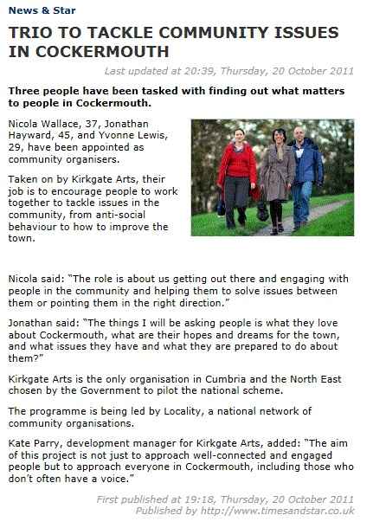

Appendix Two: Listening sheet for Maralyn Tolbert

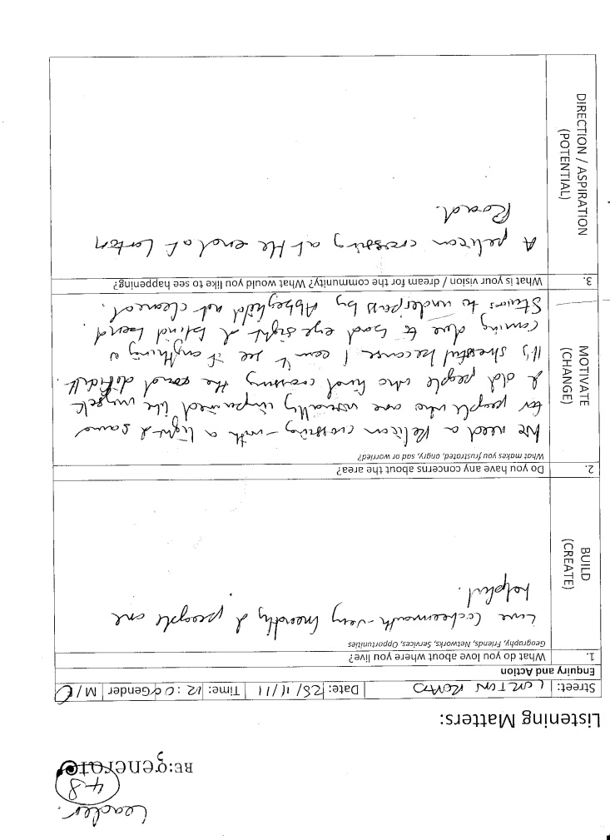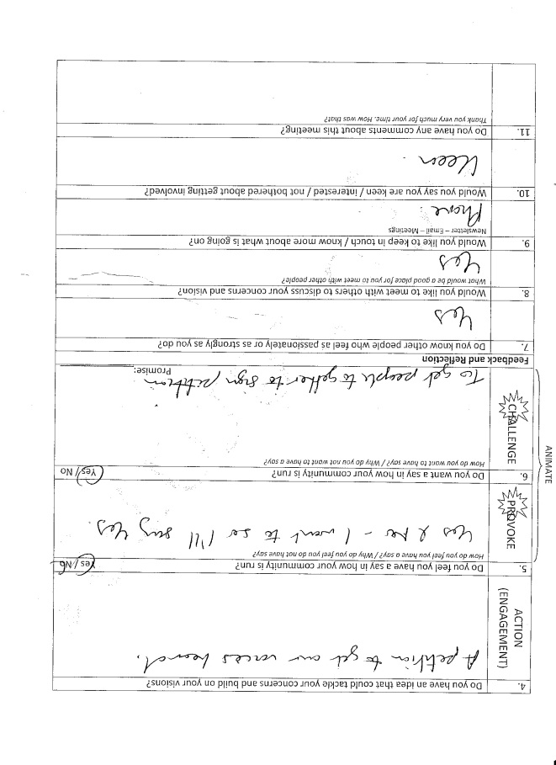

Appendix Three: Grabbing the media’s attention to the campaign

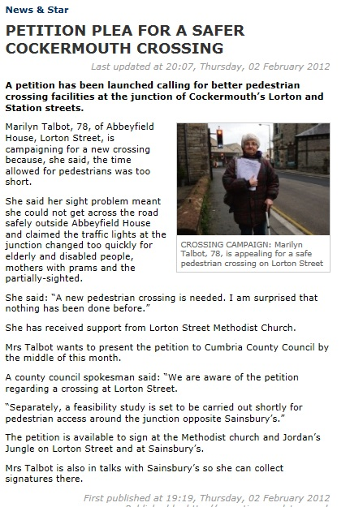

Appendix Four: Number of signatures supporting campaign.

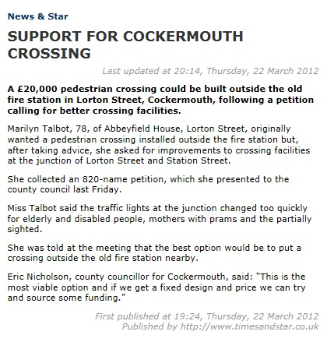

Appendix Five: Letter alongside petition sheets presented to Cumbria County Council.

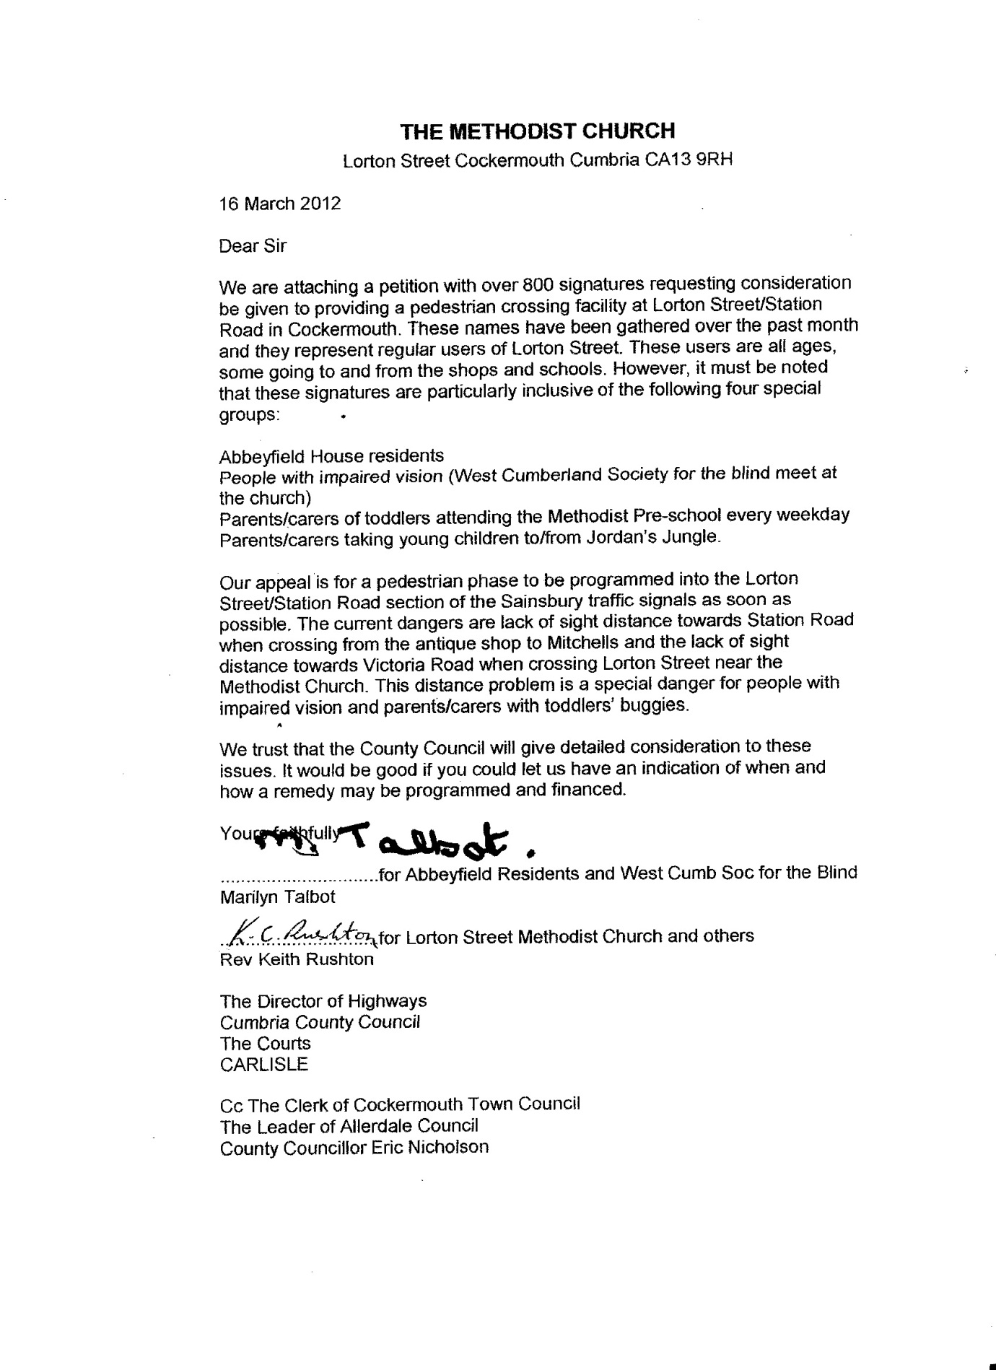

Appendix Six: Response from Cumbria County Council.

